STOPQ7
BEGIN
DECLARE a, b AS INTEGER

PRINT "Enter first number: "
INPUT a

PRINT "Enter second number: "
INPUT b

// Swap values without using a third variable
SET a = a + b
SET b = a - b
SET a = a - b

PRI

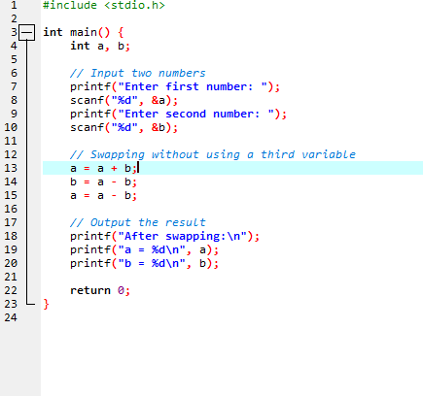
Algorithoim
Step 1: Start
Step 2: Declare two integer variables a and b
Step 3: Display message "Enter first number:"
Step 4: Input value of a
Step 5: Display message "Enter second number:"
Step 6: Input value of b
Step 7: Perform swapping using arithmetic operations:
a ← a + b
b ← a - b
a ← a - b
Step 8: Display "After swapping:"
Step 9: Display values of a and b
Step 10: Stop
Flowchart
┌──────────────────────────┐
│ Start │
└──────────┬───────────────┘
│
▼
┌──────────────────────────┐
│ Declare a, b as integer │
└──────────┬───────────────┘
│
▼
┌──────────────────────────┐
│ Input a, b │
└──────────┬───────────────┘
│
▼
┌──────────────────────────┐
│ a = a + b │
│ b = a - b │
│ a = a - b │
└──────────┬───────────────┘
│
▼
┌──────────────────────────┐
│ Print swapped values │
│ a, b │
└──────────┬───────────────┘
│
▼
┌──────────────────────────┐
│ Stop │
└──────────────────────────┘
Result
Q8
Pseudo code
BEGIN
DECLARE n, sum ← 0
PRINT "Enter a positive integer: "
READ n
FOR i ← 1 TO n DO
sum ← sum + i
END FOR
PRINT "The sum of the first", n, "natural numbers is:", sum
END
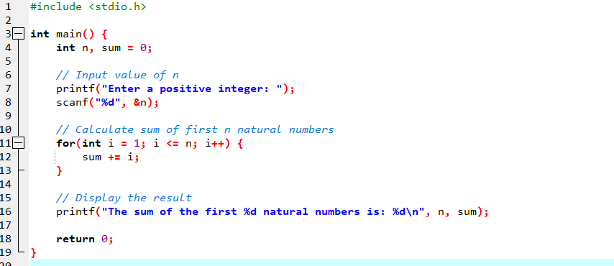
Algorithim
Step 1: Start
Step 2: Declare variables n and sum (initialize sum = 0)
Step 3: Display message "Enter a positive integer"
Step 4: Read the value of n
Step 5: Set up a loop from i = 1 to n
→ Add i to sum in each iteration (sum = sum + i)
Step 6: After the loop ends, display the sum
Step 7: Stop
Flowchart
┌────────────┐
│ Start │
└─────┬──────┘
│
▼
┌────────────┐
│ Input n │
└─────┬──────┘
│
▼
┌───────────────────┐
│ sum = 0, i = 1 │
└─────┬─────────────┘
│
▼
┌───────────────────┐
│ Is i ≤ n ? │
└─────┬───────┬─────┘
│Yes │No
▼ ▼
┌────────────┐ ┌────────────┐
│ sum+=i │ │ Display sum│
│ i = i + 1 │ └────────────┘
└────┬───────┘ │
│ ▼
└────────────>┌────────────┐
│ End │
Result

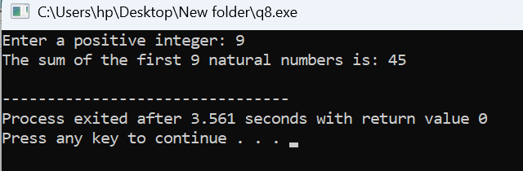

Q 9
BEGIN
DECLARE principal, rate, time, simpleInterest, compoundInterest, amount AS FLOAT

PRINT "Enter principal amount: "
READ principal

PRINT "Enter rate of interest: "
READ rate

PRINT "Enter time (in years): "
READ time

simpleInterest ← (principal * rate * time) / 100

amount ← principal * (1 + rate / 100) ^ time
compoundInterest ← amount - principal

PRINT "Simple Interest = ", simpleInterest
PRINT "Compound Interest = ", compoundInterest
END
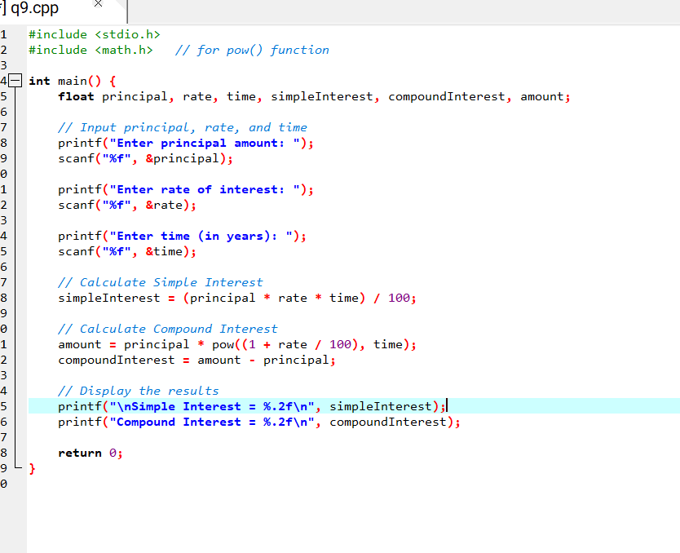
algorithim
Step 1: Start
Step 2: Declare variables: principal, rate, time, simpleInterest, compoundInterest, amount
Step 3: Read input values for principal, rate, and time
Step 4: Calculate Simple Interest (SI) using the formula:
SI = (principal × rate × time) / 100
Step 5: Calculate Amount (A) using the compound interest formula:
A = principal × (1 + rate / 100) ^ time
Step 6: Calculate Compound Interest (CI):
CI = A - principal
Step 7: Display the values of Simple Interest and Compound Interest
Step 8: Stop
flowchart
┌────────────────────┐
│ Start │
└───────┬────────────┘
↓
┌────────────────────┐
│ Declare variables │
│ principal, rate, │
│ time, SI, CI, amt │
└───────┬────────────┘
↓
┌─────────────────────────┐
│ Input principal, rate, │
│ and time │
└────────┬────────────────┘
↓
┌─────────────────────────┐
│ SI = (P * R * T) / 100 │
└────────┬────────────────┘
↓
┌─────────────────────────┐
│ amt = P * (1 + R/100)^T │
│ CI = amt - P │
└────────┬────────────────┘
↓
┌─────────────────────────┐
│ Display SI and CI │
└────────┬────────────────┘
↓
┌────────────┐
│ Stop │
└────────────┘
result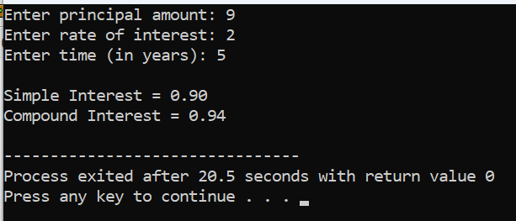

q10
pseudocode
BEGIN
DECLARE totalSeconds, hours, minutes, seconds AS INTEGER

PRINT "Enter time in seconds: "
READ totalSeconds

hours ← totalSeconds / 3600
minutes ← (totalSeconds MOD 3600) / 60
seconds ← totalSeconds MOD 60

PRINT "Time = ", hours, ":", minutes, ":", seconds
END
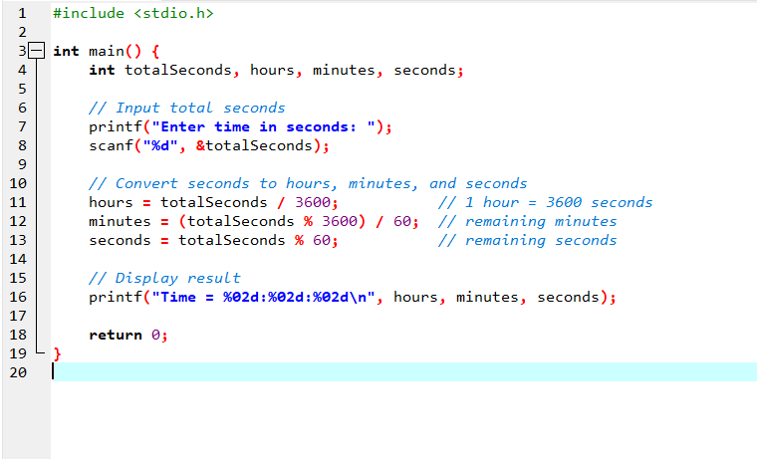
1. Algorithm
Step 1: Start
Step 2: Declare integer variables: totalSeconds, hours, minutes, seconds
Step 3: Input totalSeconds from the user
Step 4: Calculate hours as totalSeconds / 3600
Step 5: Calculate minutes as (totalSeconds % 3600) / 60
Step 6: Calculate seconds as totalSeconds % 60
Step 7: Display hours:minutes:seconds in HH:MM:SS format
Step 8: Stop
┌──────────────┐
│ Start │
└─────┬────────┘
↓
┌─────────────────┐
│ Declare variables│
│ totalSeconds, │
│ hours, minutes, │
│ seconds │
└─────┬───────────┘
↓
┌─────────────────┐
│ Input totalSeconds│
└─────┬───────────┘
↓
┌─────────────────────────────┐
│ hours = totalSeconds / 3600 │
└─────┬──────────────────────┘
↓
┌──────────────────────────────────┐
│ minutes = (totalSeconds % 3600)/60│
└─────┬───────────────────────────┘
↓
┌───────────────────────┐
│ seconds = totalSeconds % 60 │
└─────┬─────────────────┘
↓
┌───────────────────────┐
│ Display HH:MM:SS │
└─────┬─────────────────┘
↓
┌───────┐
│ Stop │
└───────┘

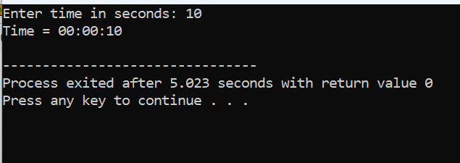
Q11 START
DECLARE num AS INTEGER

DISPLAY "Enter an integer: "
INPUT num

IF (num MOD 2 == 0) THEN
DISPLAY num, " is even."
ELSE
DISPLAY num, " is odd."
ENDI F

STOP
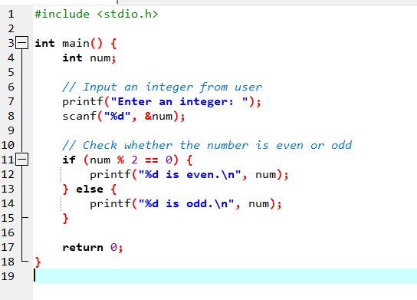
⚙️ 2. Algorithm
Step 1: Start
Step 2: Declare a variable num to store an integer.
Step 3: Prompt the user to enter an integer.
Step 4: Read the input and store it in num.
Step 5: Check if num % 2 == 0 (i.e., if the remainder when num is divided by 2 is 0).
• If TRUE → print "num is even."
• If FALSE → print "num is odd."
Step 6: Stop
┌───────────────┐
│ Start │
└──────┬────────┘
│
┌──────▼────────┐
│ Input num │
└──────┬────────┘
│
┌──────▼────────┐
│ num % 2 == 0 ? │
└──────┬────────┘
YES │ NO
┌────────┐ │ ┌────────┐
│ Print │ │ │ Print │
│ "Even" │ │ │ "Odd" │
└────┬───┘ │ └───┬────┘
│ │ │
└───────┴───────┘
│
┌──────▼────────┐
│ Stop │
└────────────────┘
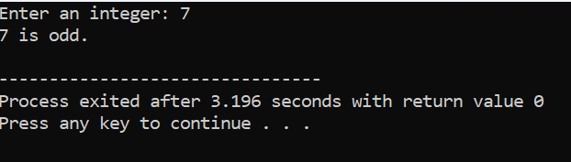
Q12
Pseudo code
START
DECLARE num AS INTEGER

DISPLAY "Enter an integer: "
INPUT num

IF num >= 0 THEN
IF num == 0 THEN
DISPLAY "The number is zero."
ELSE
DISPLAY "The number is positive."
ENDIF
ELSE
DISPLAY "The number is negative."
ENDIF

STOP
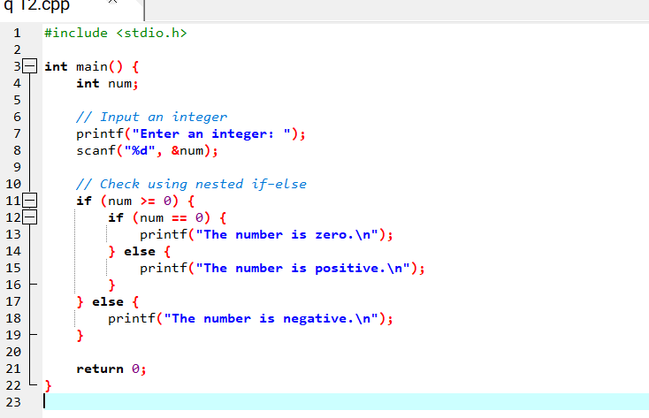
Algorithim
Step 1: Start
Step 2: Declare a variable num as integer.
Step 3: Prompt the user to enter an integer.
Step 4: Read the input and store it in num.
Step 5: Check if num is greater than or equal to 0.
- If TRUE, then:
Check if num is equal to 0.
• If TRUE → print "The number is zero."
• Else → print "The number is positive."
- If FALSE, then:
Print "The number is negative."
Step 6: Stop
Flowchart
┌──────────────┐
│ Start │
└──────┬────────┘
│
┌──────▼────────┐
│ Input num │
└──────┬────────┘
│
┌──────▼────────┐
│ num >= 0 ? │
└──────┬────────┘
YES │ NO
┌────────┐ │ ┌──────────────┐
│ num ==0? │ │ │ Print "Negative"│
└────┬─────┘ │ └───────┬────────┘
YES│NO │ │
┌─────▼─┐ ┌───▼───┐ │
│Print │ │Print │ │
│"Zero" │ │"Positive"│ │
└────┬──┘ └────┬────┘ │
│ │ │
└─────────┴─────────────┘
│
┌──────▼────────┐
│ Stop │
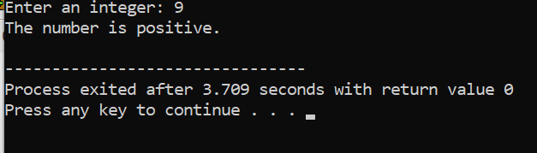
Q13
Pseudo code
START
DECLARE year AS INTEGER

DISPLAY "Enter a year: "
INPUT year

IF (year MOD 400 == 0) THEN
DISPLAY year, "is a leap year."
ELSE IF (year MOD 100 == 0) THEN
DISPLAY year, "is not a leap year."
ELSE IF (year MOD 4 == 0) THEN
DISPLAY year, "is a leap year."
ELSE
DISPLAY year, "is not a leap year."
ENDIF

STOP
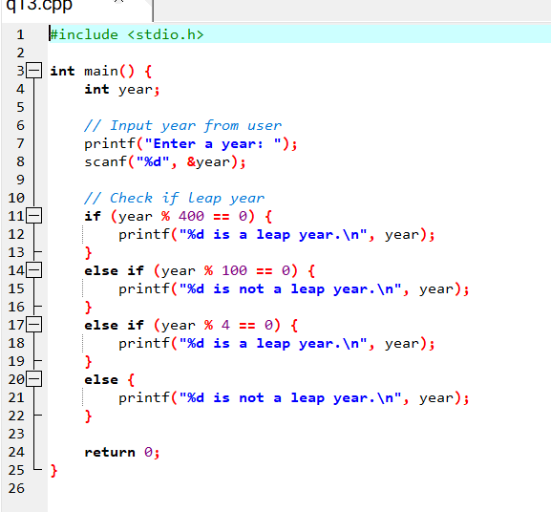
Flowchart
┌───────────────┐
│ Start │
└──────┬────────┘
│
┌──────▼────────┐
│ Input year │
└──────┬────────┘
│
┌──────▼────────┐
│ year % 400 == 0 ? │
└──────┬────────┘
YES │ NO
┌────────────┘ │
│ Print "Leap year" │
└────────────┐ │
│ │
┌──────▼────────┐
│ year % 100 == 0 ? │
└──────┬────────┘
YES │ NO
┌────────┐ │ ┌─────────────┐
│ Print │ │ │ year % 4 ==0?│
│"Not │ │ └──────┬──────┘
│Leap" │ │ YES │ NO
└────────┘ │ ┌──────▼──────┐
│ │ │ Print "Leap"│
│ │ └──────┬──────┘
│ │ │
│ │ ┌──────▼──────┐
│ │ │Print "Not │
│ │ │Leap year" │
│ │ └──────┬──────┘
└────────┴──────────┘
│
┌──────▼────────┐
│ Stop │
└────────────────┘
Algorithim
Step 1: Start
Step 2: Declare a variable year as integer.
Step 3: Prompt the user to enter a year.
Step 4: Read and store the value in year.
Step 5: Check the following conditions:
a. If year % 400 == 0, then
Print "year is a leap year."
b. Else if year % 100 == 0, then
Print "year is not a leap year."
c. Else if year % 4 == 0, then
Print "year is a leap year."
d. Else
Print "year is not a leap year."
Step 6: Stop

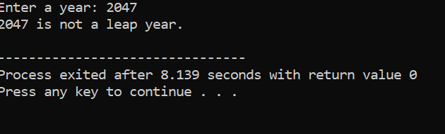
Q14 pseudo code
START
DECLARE ch AS CHARACTER

DISPLAY "Enter a character: "
INPUT ch

IF (ch >= 'a' AND ch <= 'z') OR (ch >= 'A' AND ch <= 'Z') THEN
IF (ch == 'a' OR ch == 'e' OR ch == 'i' OR ch == 'o' OR ch == 'u' OR
ch == 'A' OR ch == 'E' OR ch == 'I' OR ch == 'O' OR ch == 'U') THEN
DISPLAY "The character is a vowel."
ELSE
DISPLAY "The character is a consonant."
ENDIF
ELSE
DISPLAY "The character is not an alphabet."
ENDIF

STOP
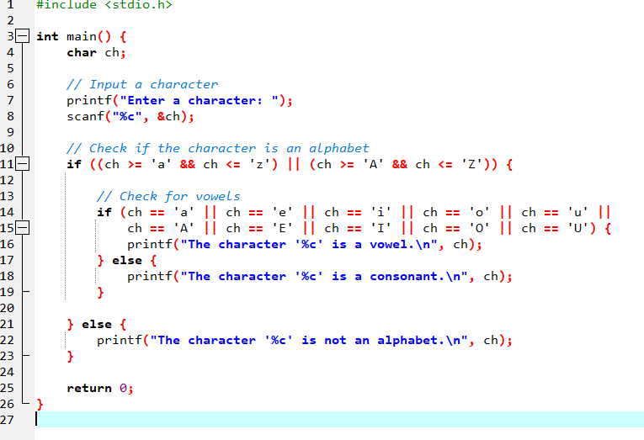
Algorithim
Step 1: Start
Step 2: Declare a variable ch as a character.
Step 3: Prompt the user to enter a character.
Step 4: Read the input and store it in ch.
Step 5: Check if ch is an alphabet:
- If (ch >= 'a' AND ch <= 'z') OR (ch >= 'A' AND ch <= 'Z'), then proceed to Step 6.
- Else, go to Step 8.
Step 6: Check if ch is a vowel:
- If ch is 'a', 'e', 'i', 'o', 'u' or 'A', 'E', 'I', 'O', 'U', then print "The character is a vowel."
Step 7: If it’s not a vowel, print "The character is a consonant."
Step 8: If ch is not an alphabet, print "The character is not an alphabet."
Step 9: Stop
Flowchart ┌───────────────┐
│ Start │
└──────┬────────┘
│
┌──────▼────────┐
│ Input ch │
└──────┬────────┘
│
┌──────▼──────────────┐
│ Is ch a letter? │
│ (a–z or A–Z) │
└──────┬──────────────┘
YES │ NO
┌────────┐ │ ┌────────────────────────┐
│Is ch a │ │ │ Print "Not an alphabet"│
│vowel? │ │ └───────────┬────────────┘
└────┬────┘ │ │
YES│NO │ │
┌────▼─┐ ┌────▼────┐ │
│Print │ │Print │ │
│"Vowel"││"Consonant"│ │
└────┬──┘ └────┬─────┘ │
│ │ │
└─────────┴────────────────┘
│
┌──────▼────────┐
│ Stop │
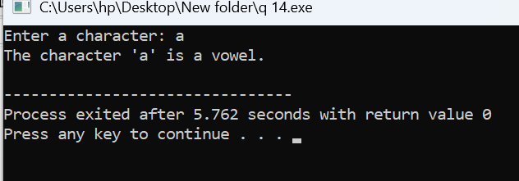
Q15 pseudo code
START
DECLARE ch AS CHARACTER

DISPLAY "Enter a character: "
INPUT ch

IF ch is an uppercase alphabet THEN
DISPLAY "The character is an uppercase alphabet."
ELSE IF ch is a lowercase alphabet THEN
DISPLAY "The character is a lowercase alphabet."
ELSE IF ch is a digit THEN
DISPLAY "The character is a digit."
ELSE
DISPLAY "The character is a special character."
ENDIF

STOP
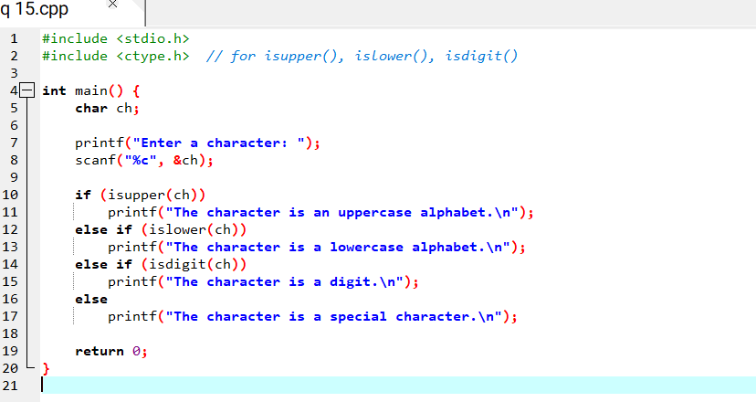
Algorithim
Step 1: Start
Step 2: Declare a variable ch as a character.
Step 3: Prompt the user to enter a character.
Step 4: Read the input and store it in ch.
Step 5: Check the following conditions in order:
a. If ch is an uppercase letter (A–Z), print "The character is an uppercase alphabet."
b. Else if ch is a lowercase letter (a–z), print "The character is a lowercase alphabet."
c. Else if ch is a digit (0–9), print "The character is a digit."
d. Else print "The character is a special character."
Step 6: Stop
Flowchart
┌───────────────┐
│ Start │
└──────┬────────┘
│
┌──────▼────────┐
│ Input ch │
└──────┬────────┘
│
┌──────▼─────────────┐
│ Is ch uppercase? │
└──────┬─────────────┘
YES │ NO
┌────────────┘ │
│ Print "Uppercase" │
└────────────┐ │
│ │
┌──────▼─────────────┐
│ Is ch lowercase? │
└──────┬─────────────┘
YES │ NO
┌────────────┘ │
│ Print "Lowercase" │
└────────────┐ │
│ │
┌──────▼─────────────┐
│ Is ch a digit? │
└──────┬─────────────┘
YES │ NO
┌────────────┘ │
│ Print "Digit" │
└────────────┐ │
│ │
┌──────▼─────────────┐
│ Print "Special char"│
└──────┬─────────────┘
│
┌──────▼────────┐
│ Stop │
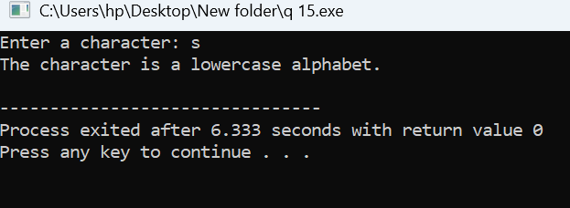
Q16
Pseudo code
START
DECLARE num1, num2, num3 AS INTEGER

DISPLAY "Enter three numbers: "
INPUT num1, num2, num3

IF num1 >= num2 THEN
IF num1 >= num3 THEN
DISPLAY num1, "is the largest number."
ELSE
DISPLAY num3, "is the largest number."
ENDIF
ELSE
IF num2 >= num3 THEN
DISPLAY num2, "is the largest number."
ELSE
DISPLAY num3, "is the largest number."
ENDIF
ENDIF

STOP
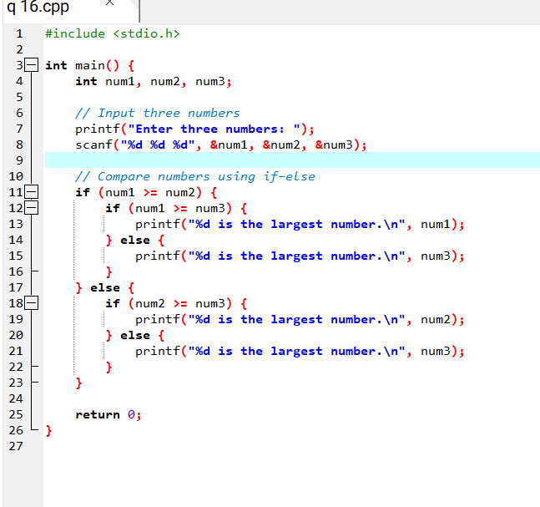
Algorithim
Step 1: Start
Step 2: Declare three integer variables: num1, num2, num3.
Step 3: Prompt the user to enter three numbers.
Step 4: Read and store the numbers in num1, num2, and num3.
Step 5: Check if num1 >= num2.
- If TRUE, then check if num1 >= num3.
• If TRUE → print "num1 is the largest number."
• Else → print "num3 is the largest number."
- If FALSE, then check if num2 >= num3.
• If TRUE → print "num2 is the largest number."
• Else → print "num3 is the largest number."
Step 6: Stop
Flowchart
┌──────────────┐
│ Start │
└──────┬────────┘
│
┌──────▼──────────────┐
│ Input num1, num2, num3 │
└──────┬──────────────┘
│
┌──────▼──────────────┐
│ Is num1 >= num2 ? │
└──────┬──────────────┘
YES │ NO
┌────────────┘ └─────────────┐
│ │
┌──▼───┐ ┌───▼───┐
│Is num1│ │Is num2│
│>=num3?│ │>=num3?│
└──┬────┘ └──┬────┘
YES│NO YES│NO
┌───▼──┐ ┌────▼───┐ ┌───▼──┐ ┌────▼───┐
│Print │ │Print │ │Print │ │Print │
│num1 │ │num3 │ │num2 │ │num3 │
│largest││largest │ │largest││largest │
└───┬───┘ └───┬───┘ └───┬───┘ └───┬───┘
│ │ │ │
└─────────┴──────────────────────┴─────────┘
│
┌──────▼────────┐
│ Stop │
└────────────────┘
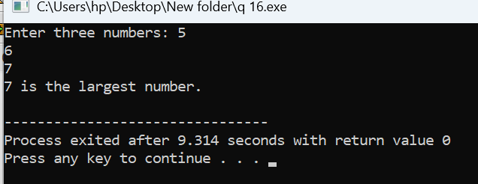
Q17
Pseudo code
START
DECLARE a, b, c, discriminant, root1, root2, realPart, imagPart AS REAL

DISPLAY "Enter coefficients a, b, and c: "
INPUT a, b, c

CALCULATE discriminant = b*b - 4*a*c

IF a == 0 THEN
DISPLAY "This is not a quadratic equation."
ELSE
IF discriminant > 0 THEN
root1 = (-b + √discriminant) / (2*a)
root2 = (-b - √discriminant) / (2*a)
DISPLAY "Roots are real and distinct."
DISPLAY root1, root2
ELSE IF discriminant == 0 THEN
root1 = root2 = -b / (2*a)
DISPLAY "Roots are real and equal."
DISPLAY root1
ELSE
realPart = -b / (2*a)
imagPart = √(-discriminant) / (2*a)
DISPLAY "Roots are imaginary (complex conjugates)."
DISPLAY realPart ± imagPart * i
ENDIF
ENDIF

STOP
algorithim
Step 1: Start
Step 2: Declare variables: a, b, c, discriminant, root1, root2, realPart, imagPart.
Step 3: Prompt the user to enter the coefficients a, b, and c.
Step 4: Read and store their values.
Step 5: Compute the discriminant:
discriminant = b * b - 4 * a * c
Step 6: Check if a == 0.
- If TRUE → print "This is not a quadratic equation." and go to Step 10.
Step 7: If a != 0, check discriminant conditions:
- If discriminant > 0:
• Roots are real and distinct.
• Compute roots:
root1 = (-b + sqrt(discriminant)) / (2 * a)
root2 = (-b - sqrt(discriminant)) / (2 * a)
• Print both roots.
- Else if discriminant == 0:
• Roots are real and equal.
• Compute: root1 = root2 = -b / (2 * a)
• Print the root.
- Else:
• Roots are imaginary (complex conjugates).
• Compute:
realPart = -b / (2 * a)
imagPart = sqrt(-discriminant) / (2 * a)
• Print realPart ± imagPart * i.
Step 8: Stop
flowchart
┌──────────────┐
│ Start │
└──────┬────────┘
│
┌──────▼─────────────┐
│ Input a, b, c │
└──────┬─────────────┘
│
┌──────▼─────────────┐
│ Calculate D = b²-4ac│
└──────┬─────────────┘
│
┌──────▼─────────────┐
│ Is a == 0 ? │
└──────┬─────────────┘
YES│ │NO
┌────────────┐ ┌──────────────┐
│Print "Not │ │Is D > 0 ? │
│quadratic" │ └──────┬───────┘
└────────────┘ YES │ NO
│ │
┌───────────▼┐ ┌▼─────────────┐
│Real & │ │Is D == 0 ? │
│Distinct │ └────┬─────────┘
└────┬───────┘ │
│ YES │ NO
┌────────────▼┐ ┌─────▼───────┐
│Compute roots│ │Real & Equal │
│Print roots │ │Compute root │
└────┬────────┘ │Print root │
│ └─────┬───────┘
│ │
│ ┌─────▼───────────────┐
│ │Imaginary Roots │
│ │Compute real & imag │
│ │Print conjugate roots │
│ └────────┬────────────┘
│ │
└─────────────────────────┘
│
┌──────▼────────┐
│ Stop │
└────────────────┘

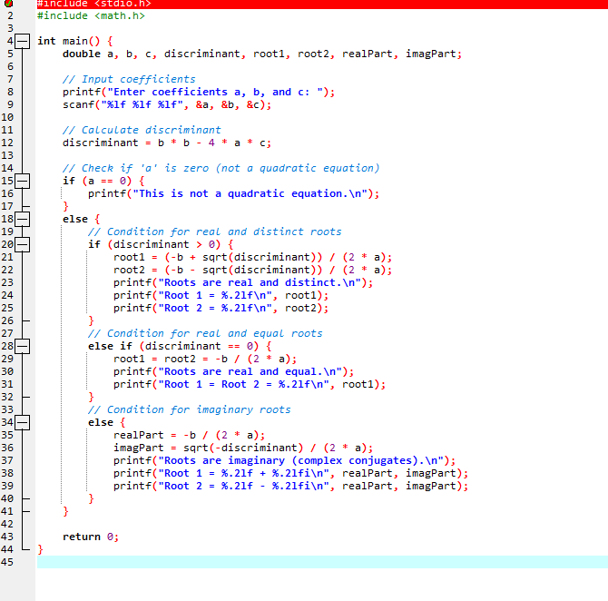
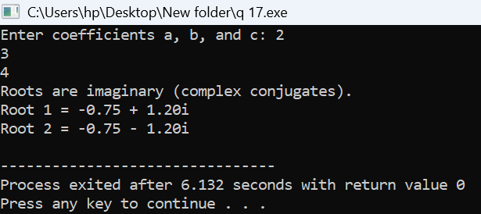
Q18
Pseudo code
START
DECLARE percentage AS REAL

DISPLAY "Enter your percentage (0-100): "
INPUT percentage

IF percentage < 0 OR percentage > 100 THEN
DISPLAY "Invalid percentage! Please enter a value between 0 and 100."
ELSE
IF percentage >= 90 THEN
DISPLAY "Grade: A"
ELSE IF percentage >= 80 THEN
DISPLAY "Grade: B"
ELSE IF percentage >= 70 THEN
DISPLAY "Grade: C"
ELSE IF percentage >= 60 THEN
DISPLAY "Grade: D"
ELSE
DISPLAY "Grade: F"
ENDIF
ENDIF

STOP
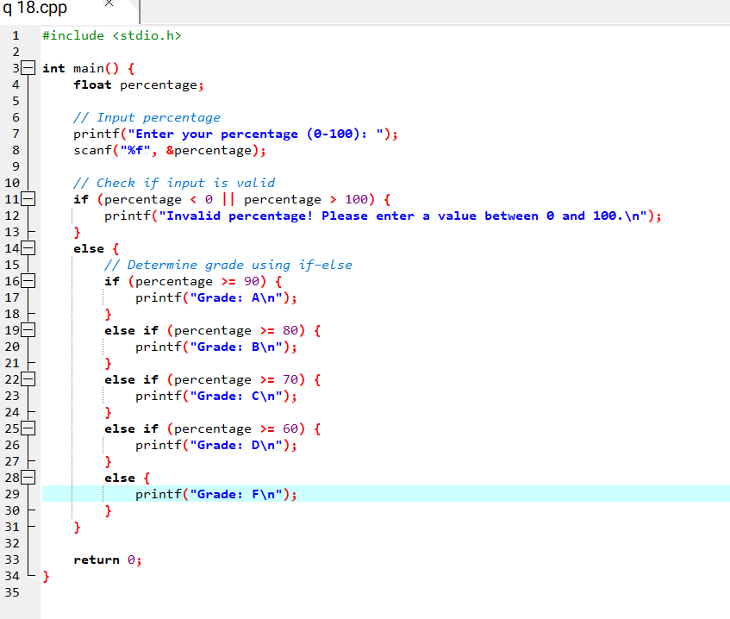
Algorithim
Step 1: Start
Step 2: Declare a variable percentage (float).
Step 3: Prompt the user to enter their percentage.
Step 4: Read and store the value of percentage.
Step 5: Check if percentage is less than 0 or greater than 100.
- If TRUE, print “Invalid percentage!” and go to Step 10.
Step 6: If the input is valid, compare the value to determine the grade:
- If percentage >= 90, print “Grade: A”.
- Else if percentage >= 80, print “Grade: B”.
- Else if percentage >= 70, print “Grade: C”.
- Else if percentage >= 60, print “Grade: D”.
- Else, print “Grade: F”.
Step 7: Stop.

┌──────────────┐
│ Start │
└──────┬────────┘
│
┌──────▼─────────────┐
│ Input percentage │
└──────┬─────────────┘
│
┌──────▼────────────────────────────┐
│ Is percentage < 0 OR > 100 ? │
└──────┬────────────────────────────┘
YES │ NO
┌────────────┘ │
│ Print "Invalid" │
└────────────┐ │
│ │
┌──────▼─────────────┐
│ percentage >= 90 ? │
└──────┬─────────────┘
YES │ NO
┌────────────┘ │
│ Print "Grade A" │
└────────────┐ │
│ │
┌──────▼─────────────┐
│ percentage >= 80 ? │
└──────┬─────────────┘
YES │ NO
┌────────────┘ │
│ Print "Grade B" │
└────────────┐ │
│ │
┌──────▼─────────────┐
│ percentage >= 70 ? │
└──────┬─────────────┘
YES │ NO
┌────────────┘ │
│ Print "Grade C" │
└────────────┐ │
│ │
┌──────▼─────────────┐
│ percentage >= 60 ? │
└──────┬─────────────┘
YES │ NO
┌────────────┘ │
│ Print "Grade D" │
└────────────┐ │
│ │
│ ┌────▼───────┐
│ │Print "F" │
│ └────┬───────┘
│ │
└─────────┘
│
┌────────────▼───────────┐
│ Stop │
└────────────────────────┘

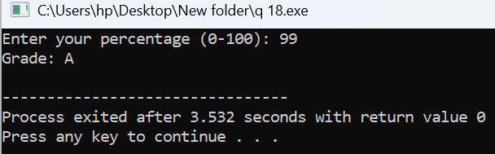
Q19
Pseudo code
BEGIN
DECLARE side1, side2, side3 AS FLOAT

PRINT "Enter three sides of the triangle: "
INPUT side1, side2, side3

IF (side1 + side2 > side3) AND (side1 + side3 > side2) AND (side2 + side3 > side1) THEN
IF (side1 == side2) AND (side2 == side3) THEN
PRINT "The triangle is Equilateral."
ELSE IF (side1 == side2) OR (side1 == side3) OR (side2 == side3) THEN
PRINT "The triangle is Isosceles."
ELSE
PRINT "The triangle is Scalene."
END IF
ELSE
PRINT "The given sides do not form a valid triangle."
END IF
END
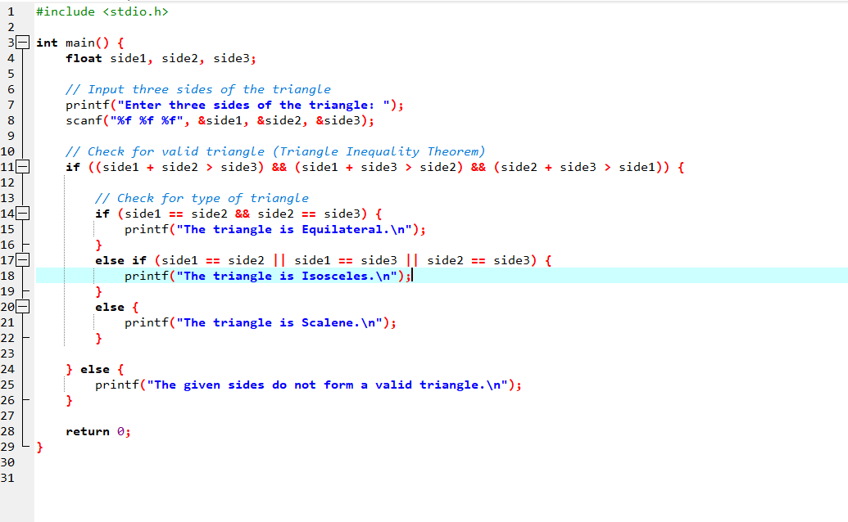
Algorithim
Step 1: Start
Step 2: Declare three variables: side1, side2, and side3
Step 3: Prompt the user to enter the three sides of a triangle
Step 4: Read the three side values
Step 5: Check if the three sides can form a valid triangle using the Triangle Inequality Theorem:
If
(side1 + side2 > side3) AND
(side1 + side3 > side2) AND
(side2 + side3 > side1)
then proceed
otherwise, display “The given sides do not form a valid triangle” and go to Step 10.
Step 6: If all three sides are equal → display “Equilateral triangle”
Step 7: Else if any two sides are equal → display “Isosceles triangle”
Step 8: Else → display “Scalene triangle”
Step 9: End the program normally
Step 10: Stop
Flowchart
+----------------------+
| Start |
+----------------------+
|
v
+----------------------+
| Input side1, side2, |
| side3 |
+----------------------+
|
v
+----------------------------------+
| Check: (side1+side2>side3) AND |
| (side1+side3>side2) AND |
| (side2+side3>side1) |
+----------------------------------+
| Yes | No
v v
+----------------------+ +--------------------------+
| Are all sides equal? | | Print: Not a valid |
| side1==side2==side3 | | triangle |
+----------------------+ +--------------------------+

| Yes | No
v v
+----------------------+
| Print: Equilateral |
+----------------------+
|
+----------------------+
| Any two sides equal? |
| side1==side2 OR |
| side1==side3 OR |
| side2==side3 |
+--
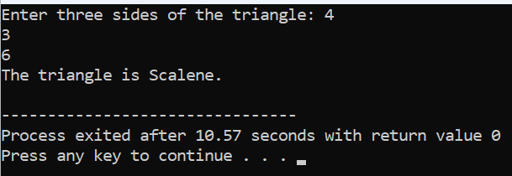
Q20
Pseudo code
START
DECLARE integer day
PRINT "Enter a number (1-7):"
READ day

SWITCH day
CASE 1:
PRINT "Monday"
CASE 2:
PRINT "Tuesday"
CASE 3:
PRINT "Wednesday"
CASE 4:
PRINT "Thursday"
CASE 5:
PRINT "Friday"
CASE 6:
PRINT "Saturday"
CASE 7:
PRINT "Sunday"
DEFAULT:
PRINT "Invalid input! Please enter a number between 1 and 7."
END SWITCH
END
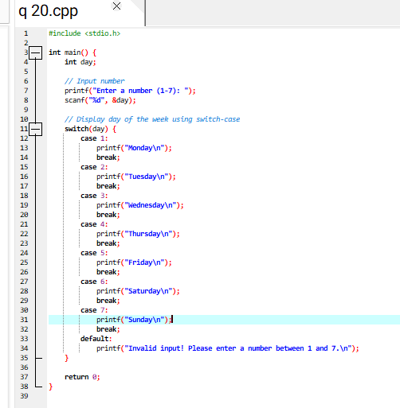
Algorithim
• Start.
• Declare an integer variable day.
• Prompt the user: "Enter a number (1-7)".
• Read the input and store it in day.
• Use a switch-case to check the value of day:
- If day == 1, print "Monday".
- If day == 2, print "Tuesday".
- If day == 3, print "Wednesday".
- If day == 4, print "Thursday".
- If day == 5, print "Friday".
- If day == 6, print "Saturday".
- If day == 7, print "Sunday".
- If day is not between 1 and 7, print "Invalid input! Please enter a number between 1 and 7."
• End.
Flowchart
┌─────────┐
│ Start │
└────┬────┘
│
▼
┌────────────────┐
│ Input day (1-7)│
└────┬───────────┘
│
▼
┌───────────────┐
│ Is day = 1? │
└───┬───────────┘
Yes │ No
┌───▼───┐ ┌───────────────┐
│Print │ │ Is day = 2? │
│Monday │ └────┬──────────┘
└───┬───┘ │
▼ │
End ... (repeat for 3-7)
│
▼
┌─────────────┐
│ Invalid │
│ input! │
└────┬────────┘
▼
End

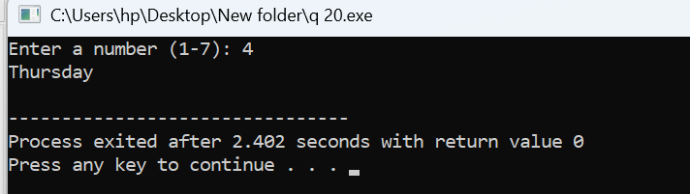
q21
pseudo code
START
DECLARE integer month, year
PRINT "Enter month number (1-12):"
READ month

IF month = 2 THEN
PRINT "Enter year:"
READ year
ENDIF

SWITCH month
CASE 1:
PRINT "January - 31 days"
CASE 2:
IF (year % 4 = 0 AND year % 100 != 0) OR (year % 400 = 0) THEN
PRINT "February - 29 days (Leap Year)"
ELSE
PRINT "February - 28 days"
ENDIF
CASE 3:
PRINT "March - 31 days"
CASE 4:
PRINT "April - 30 days"
CASE 5:
PRINT "May - 31 days"
CASE 6:
PRINT "June - 30 days"
CASE 7:
PRINT "July - 31 days"
CASE 8:
PRINT "August - 31 days"
CASE 9:
PRINT "September - 30 days"
CASE 10:
PRINT "October - 31 days"
CASE 11:
PRINT "November - 30 days"
CASE 12:
PRINT "December - 31 days"
DEFAULT:
PRINT "Invalid month number! Please enter 1-12."
END SWITCH
END

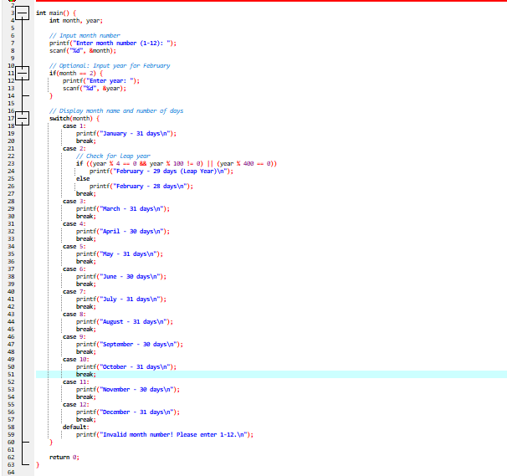
Algorithim
- Start.
- Declare integer variables month and year.
- Prompt the user: "Enter month number (1-12)".
- Read input into month.
- If month == 2, ask the user to enter the year and read it.
- Use a switch statement to check the value of month:
  - 1: Print "January - 31 days"
  - 2: Check for leap year:
    - If (year % 4 == 0 && year % 100 != 0) || (year % 400 == 0) → Print "February - 29 days (Leap Year)"
    - Else → Print "February - 28 days"
  - 3: Print "March - 31 days"
  - 4: Print "April - 30 days"
  - 5: Print "May - 31 days"
  - 6: Print "June - 30 days"
  - 7: Print "July - 31 days"
  - 8: Print "August - 31 days"
  - 9: Print "September - 30 days"
  - 10: Print "October - 31 days"
  - 11: Print "November - 30 days"
  - 12: Print "December - 31 days"
  - Default: Print "Invalid month number! Please enter 1-12."
- End
Flowchart
┌─────────┐
│ Start │
└────┬────┘
│
▼
┌────────────────┐
│ Input month (1-12) │
└────┬───────────┘
│
▼
┌───────────────┐
│ Is month = 2? │
└────┬──────────┘
Yes │ No
▼
┌───────────────┐
│ Input year │
└────┬──────────┘
▼
┌───────────────────────────┐
│ Is year leap year? │
│ (year%4==0 && year%100!=0 │
│ || year%400==0) │
└────┬───────────────┘
Yes │ No
▼ ▼
Feb -29 Feb -28
│ │
▼ ▼
(continue with switch for 1,3-12)
│
▼
Print month name & days
│
▼
┌─────────┐
│ End │
└─────────┘
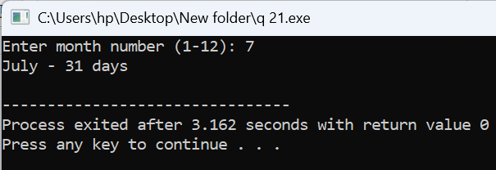
Q22
Pseudo code
START
DECLARE float costPrice, sellingPrice, profit, loss

PRINT "Enter Cost Price:"
READ costPrice

PRINT "Enter Selling Price:"
READ sellingPrice

IF sellingPrice > costPrice THEN
profit = sellingPrice - costPrice
PRINT "Profit =", profit
PRINT "Profit Percentage =", (profit / costPrice) * 100, "%"
ELSE IF costPrice > sellingPrice THEN
loss = costPrice - sellingPrice
PRINT "Loss =", loss
PRINT "Loss Percentage =", (loss / costPrice) * 1*
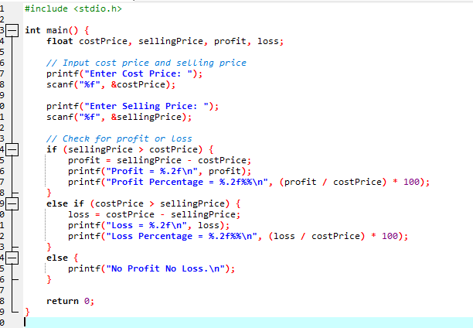
Algorithim
• Start.
• Declare float variables costPrice, sellingPrice, profit, loss.
• Prompt the user: "Enter Cost Price" and read costPrice.
• Prompt the user: "Enter Selling Price" and read sellingPrice.
• Check the following conditions:
- If sellingPrice > costPrice:
  - Calculate profit = sellingPrice - costPrice.
  - Display Profit and Profit Percentage = (profit / costPrice) * 100.
- Else if costPrice > sellingPrice:
  - Calculate loss = costPrice - sellingPrice.
  - Display Loss and Loss Percentage = (loss / costPrice) * 100.
- Else:
  - Display "No Profit No Loss".
• End.
Flowchart
┌─────────┐
│ Start │
└────┬────┘
│
▼
┌───────────────────┐
│ Input Cost Price │
└────┬──────────────┘
│
▼
┌────────────────────┐
│ Input Selling Price │
└────┬───────────────┘
│
▼
┌─────────────────────────┐
│ sellingPrice > costPrice?│
└────┬───────────────┘
Yes │ No
▼ ▼
┌───────────────┐ ┌─────────────────────┐
│ profit = SP-CP│ │ costPrice > SP? │
│ PRINT Profit │ └────┬──────────────┘
│ PRINT %Profit │ Yes │ No
└─────┬─────────┘ ▼ ▼
▼ ┌───────────────┐ ┌───────────────┐
└──────────>│ loss = CP-SP │ │ Print "No Profit│
│ Print Loss │ │ No Loss" │
│ Print %Loss │ └───────────────┘
└─────┬─────────┘
▼
┌─────────┐
│ End │
└─────────┘
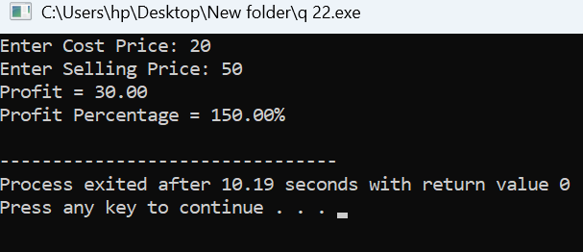
Q23
Pseudo code
START
DECLARE integer lateDays, fine = 0

PRINT "Enter number of late days:"
READ lateDays

IF lateDays <= 0 THEN
PRINT "No fine. Book returned on time."
ELSE IF lateDays <= 5 THEN
fine = lateDays * 2
PRINT "Fine =", fine
ELSE IF lateDays <= 10 THEN
fine = 5*2 + (lateDays - 5)*4
PRINT "Fine =", fine
ELSE IF lateDays <= 30 THEN
fine = 5*2 + 5*4 + (lateDays - 10)*6
PRINT "Fine =", fine
ELSE
PRINT "Membership Cancelled due to late return exceeding 30 days."
ENDIF
END
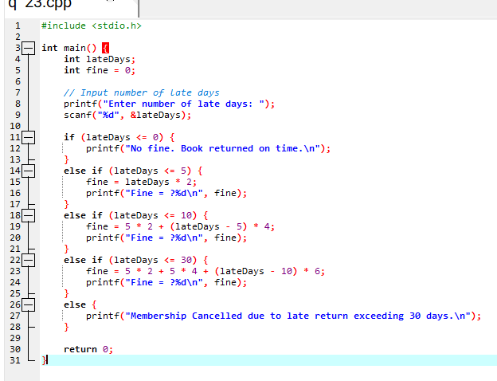
Algorithim
- Start.
- Declare integer variables lateDays and fine (initialize fine = 0).
- Prompt the user: "Enter number of late days" and read lateDays.
- Check the number of late days:
  - If lateDays <= 0:
    - Print "No fine. Book returned on time."
  - Else if lateDays <= 5:
    - Calculate fine = lateDays * 2
    - Print "Fine = fine"
  - Else if lateDays <= 10:
    - Calculate fine = 5*2 + (lateDays-5)*4
    - Print "Fine = fine"
  - Else if lateDays <= 30:
    - Calculate fine = 5*2 + 5*4 + (lateDays-10)*6
    - Print "Fine = fine"
  - Else (lateDays > 30):
    - Print "Membership Cancelled due to late return exceeding 30 days."
- End.
Flowchart
┌─────────┐
│ Start │
└────┬────┘
│
▼
┌─────────────────────┐
│ Input number of late │
│ days │
└────┬────────────────┘
│
▼
┌─────────────────────┐
│ lateDays <= 0 ? │
└────┬───────────────┘
Yes │ No
▼ ▼
Print "No fine" ┌─────────────────────┐
│ lateDays <= 5 ? │
└────┬───────────────┘
Yes │ No
▼ ▼
fine = lateDays*2 ┌─────────────────────┐
Print fine │ lateDays <= 10 ? │
└────┬───────────────┘
Yes │ No
▼ ▼
fine = 5*2 + (lateDays-5)*4 ┌─────────────────────┐
Print fine │ lateDays <= 30 ? │
└────┬───────────────┘
Yes │ No
▼ ▼
fine = 5*2+5*4+(lateDays-10)*6 Print "Membership Cancelled"
Print fine
│
▼
┌─────────┐
│ End │
└─────────┘
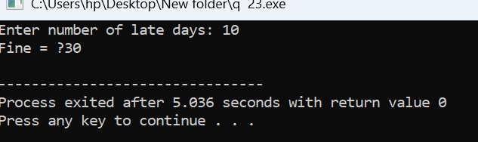
Q24
Pseudo code
START
DECLARE integer units, bill = 0

PRINT "Enter number of units consumed:"
READ units

IF units <= 0 THEN
PRINT "Invalid input. Units must be positive."
ELSE IF units <= 100 THEN
bill = units * 5
ELSE IF units <= 200 THEN
bill = 100*5 + (units - 100)*7
ELSE IF units <= 300 THEN
bill = 100*5 + 100*7 + (units - 200)*10
ELSE
bill = 100*5 + 100*7 + 100*10 + (units - 300)*12
ENDIF

IF units > 0 THEN
PRINT "Electricity Bill =", bill
ENDIF
END
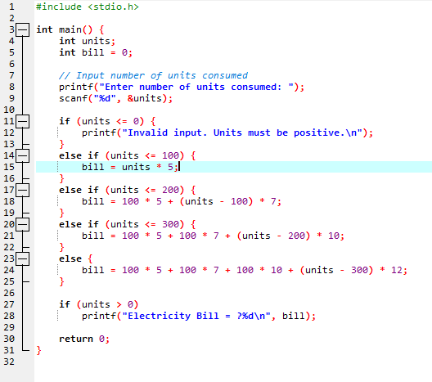
Algorithim
- Start.
- Declare integer variables units and bill (initialize bill = 0).
- Prompt the user: "Enter number of units consumed" and read units.
- Check the number of units:
  - If units <= 0:
    - Print "Invalid input. Units must be positive."
  - Else if units <= 100:
    - Calculate bill = units * 5.
  - Else if units <= 200:
    - Calculate bill = 100*5 + (units-100)*7.
  - Else if units <= 300:
    - Calculate bill = 100*5 + 100*7 + (units-200)*10.
  - Else (units > 300):
    - Calculate bill = 100*5 + 100*7 + 100*10 + (units-300)*12.
- If units > 0, print "Electricity Bill = bill".
- End.
Flowchart
┌─────────┐
│ Start │
└────┬────┘
│
▼
┌───────────────────────────┐
│ Input number of units │
└────┬──────────────────────┘
│
▼
┌───────────────────────────┐
│ units <= 0 ? │
└────┬───────────────┘
Yes │ No
▼ ▼
Print "Invalid input" ┌─────────────────────────┐
│ units <= 100 ? │
└────┬──────────────────┘
Yes │ No
▼ ▼
bill = units*5 ┌─────────────────────────┐
│ units <= 200 ? │
└────┬──────────────────┘
Yes │ No
▼ ▼
bill = 100*5 + (units-100)*7 ┌─────────────────────────┐
│ units <= 300 ? │
└────┬─────────────────┘
Yes │ No
▼ ▼
bill = 100*5 + 100*7 + (units-200)*10
bill = 100*5 + 100*7 + 100*10 + (units-300)*12
│
▼
Print "Electricity Bill = bill"
│
▼
┌─────────┐
│ End │
